Patricia Pérez González 70863211-G

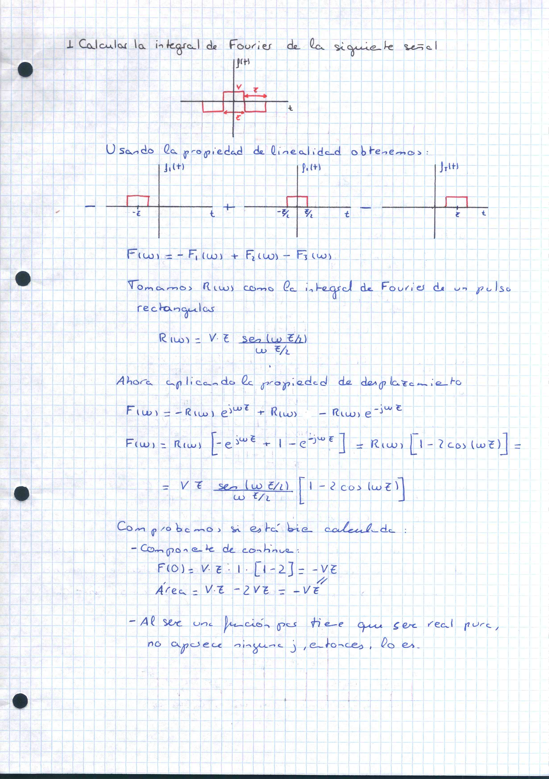

Patricia Pérez González 70863211-G
